What will we be learning?  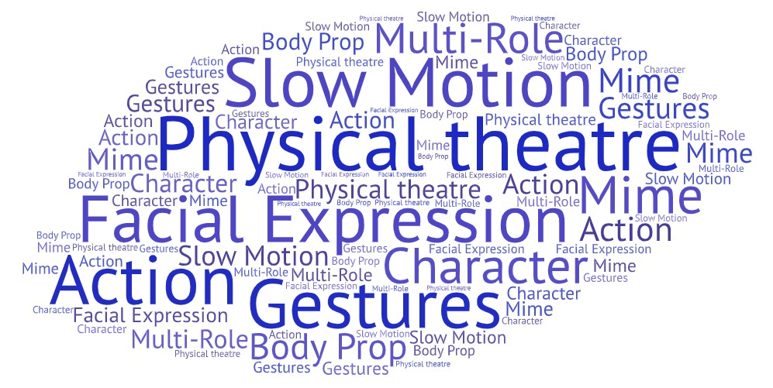 |  | Why this? Why now?  Year 8  To develop the tools of physical theatre and apply them within a range of performance work  Year 9  To learn about a physical theatre practitioner. To apply their frameworks to your own performance piece. | Key Words:  Physical theatre  Facial expressions  Gestures  Slow Motion  Character  Actions  Body Prop  Mime  Multi-Role
What will we learn?
How do we present meaning to an audience through the style of ‘Physical Theatre’?
Developing ‘The Actors Toolbox’ in Year 8:  What is physical theatre?  How can I communicate a story without using words?  What is body prop? | What is the imagination tool?  How can I create an object if it is not there?  How can I use physical skills to present a range of characters?
What opportunities are there for wider study?
Year 7 Drama Club – to gain further experience of developing performance work
Senior Drama Club (Year 8, 9 and 10) – to perform in projects such as ‘National Theatre Connections Plays’
Theatre Trips – Visit a local theatre or head to the West End in London to see a live performance
Visit the National Theatre Live website to stream a live theatre performance
Visit BBC Bitesize to find out more about physical theatre:
https://www.bbc.co.uk/bitesize/guides/ztfk6sg/revision/1
How will I be assessed?
Creating – Explore and interpret ideas during the rehearsals in response to the stylistic features of ‘Physical Theatre’. For example, body prop, mime, imagination tool and silent movies. Contribute consistently through the rehearsal process giving creative and imaginative ideas.

Performance - To sustain a character throughout a performance. To understand your role within the piece and to present this with confidence.

Responding – To use technical terms with confidence when talking or writing about dramas you have seen or participated in. For example, ‘the use of body language such as the slouched posture showed us that the character was bored’.

